**DSA Homework 2**

**Ruiyu Zhang || rz213**

**1. Implement Shell Sort which reverts to insertion sort. (Use the increment sequence 7, 3, 1). Create a table or a plot for the total number of comparisons made in the sorting the data for both cases (insertion sort phase and shell sort phase). Explain why Shell Sort is more effective than Insertion sort in this case.**

A:

Code is written and tested using python3.5, “.py” file is attached

|  |  |  |  |  |  |  |  |
| --- | --- | --- | --- | --- | --- | --- | --- |
|  | data-size | 512 | 1024 | 2048 | 4096 | 8192 | 16384 |
| Time  (ms) | insert | 21.124 | 85.680 | 334.058 | 1354.999 | 5372.858 | 21759.449 |
| shell | 4.556 | 17.510 | 67.523 | 260.893 | 1011.824 | 4059.274 |
| Swaps | insert | 64668 | 265060 | 1032286 | 4214951 | 16686014 | 67501453 |
| shell | 11576 | 43692 | 163474 | 641751 | 2516854 | 10104167 |
| Comps | insert | 65114 | 253900 | 1061413 | 4221067 | 16581008 | 67032650 |
| shell | 11756 | 43430 | 173545 | 643335 | 2471730 | 9942724 |

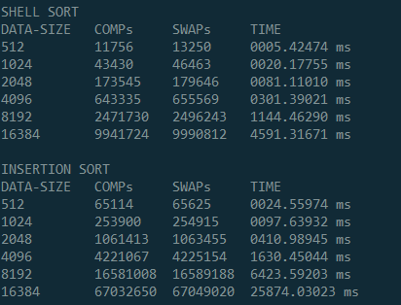

From the result, we can easily tell that shell sort is much faster than insertion sort.

The reason is that shell sort has a worst-case complexity of

**O(n3/2)**

for **2k-1** sequence (1,3,7,etc)

While insertion sort has a worst-case complexity of

**O(n2)**

So as data size grow bigger, insertion sort grows faster in running time. And this is contributed a lot by number of swaps and comparisons performed, which is also included in the statistics above in the form.

**2. The Kendall Tau distance is a variant of the "number of inversions" we discussed in class. It is defined as the number of pairs that are in different order in two permutations. Write an efficient program that computes the Kendall Tau distance in less than quadratic time on average. Plot your results and discuss. Use the dataset provided here. Note: data0.* for convenience is an**

**ordered set of numbers (in powers of two). data1.* are shuffled data sets of sizes (as given by "*").**

Data Set for Questions above: https://drive.google.com/file/d/0B4xMi5S-VFVRVWh0YzV6bmFLMjQ/view?usp=sharing

A:

Code is written and tested using python3.5, “.py” file is attached.

With inspiration from Prof. William R. Knight’s paper “***A Computer Method for Calculating Kendall’s Tau with Ungrouped Data***”, published 1966.

|  |  |  |  |  |  |  |
| --- | --- | --- | --- | --- | --- | --- |
| Data Size | 1024 | 2048 | 4096 | 8192 | 16384 | 32768 |
| INVs Found | 264541 | 1027236 | 4183804 | 16928767 | 66641183 | 267933908 |

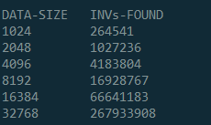

This algorithm has a complexity of

**O(n*log n)**

because it is based on Merge Sort algorithm.

**Note**: please modify the file path in the code before you do test on your device.

**3. Create a data set of 8192 entries which has in the following order: 1024 repeats of 1, 2048 repeats of 11, 4096 repeats of 111 and 1024 repeats of 1111. Write a sort algorithm that you think will sort this set "most" effectively. Explain why you think so.**

A:

Code is written and tested using python3.5, “.py” file is attached.

My algorithm has a **time-complexity** of

**O(n)**

and it will only scan every element of the data set for **exactly once**. However, it will **skip manipulating** (popping, in fact) element ‘111’, which means it will manipulate the list for only 4096(=8192-4096) times. The **time complexity for item manipulation** is:

**O(n/2)**

as a result.

**Method:**

scan and pop on encountering ‘1’, ‘11’, ‘1111’ (skips ‘111’).

put popped data in temporary list.

put list back together by ‘extending’ list and put everything back at ‘data’.

**4. Implement the two versions of Merge Sort that we discussed in class. Create a table or a plot for the total number of comparisons to sort the data (using data set here) for both cases. Explain.**

A:

Code is written and tested using python3.5, “.py” file is attached.

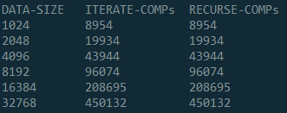

The result shows that whichever way we use to perform merge-sort, the total comparison trials will remain the same.

The reason is simple: the total comparison times depends on the length of the array, regardless of either the way the program runs or whether the array is sorted or not. This example shows us the mutual parts of iteration and recursion.

**5. Implement Quicksort using median-of-three to determine the partition element. Compare the performance of Quicksort with the Merge Sort implementation and dataset from Q4. Is there any noticeable difference when you use N=7 as the cut-off to insertion sort. Experiment if there is any value of "cut-off to insertion" at which the performance inverts.**

A:

Code is written and tested using python3.5, “.py” file is attached.

When N=7, Time for Quicksort is 1724.60 ms and time for Mergesort is 1942.92 ms.

My program runs 49 times in loop, with cutoff values ranging from 1 to 49. The result is plotted below. We can tell that both algorithms show similar trends, and the performance invert appear between N=5 and N=11.

The test is based on sorting a 300,000-membered random list. **Dataset from Q4 is not used here**, because the list is too short to show features of both kinds of sorting algorithms (program completed in microseconds, highly disturbed by compiler).

**6. View the following Data Set here. The column on the left is the original input of strings to be sorted or shuffled; the column on the extreme right are the string in sorted order; the other columns are the contents at some intermediate step during one of the 8 algorithms listed below. Match up each algorithm under the corresponding column. Use each algorithm exactly once: (1) Knuth shuffle (2) Selection sort(3) Insertion sort (4) Merge Sort(top-down)(5) Merge Sort (bottom-up) (6) Quicksort (standard, no shuffle) (7) Quicksort (3-way, no shuffle) (8) Heapsort.**

[location of data: <https://sakai.rutgers.edu/access/content/group/f73f2fd4-280d-4e7c-8cf2-9cc34bcffcff/HW-DataSet/algorithm-stage.png>]

A:

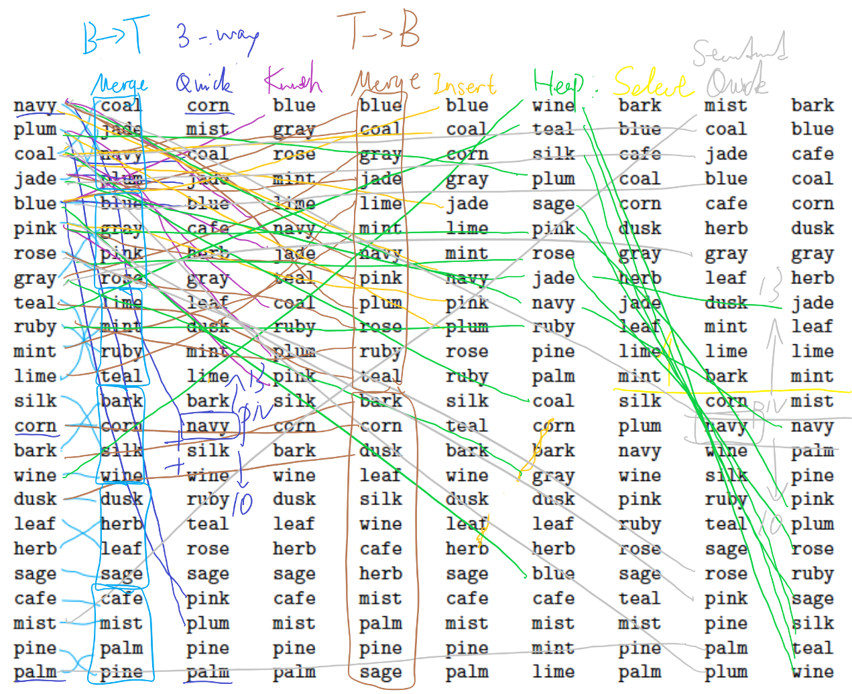

Column 1: Raw data.

Column 2: Merge sort, bottom to top.

Column 3: Quick sort, 3-way.

Column 4: Knuth shuffle.

Column 5: Merge sort, top to bottom.

Column 6: Insertion sort.

Column 7: Heap sort.

Column 8: Selection sort.

Column 9: Quick sort, standard.